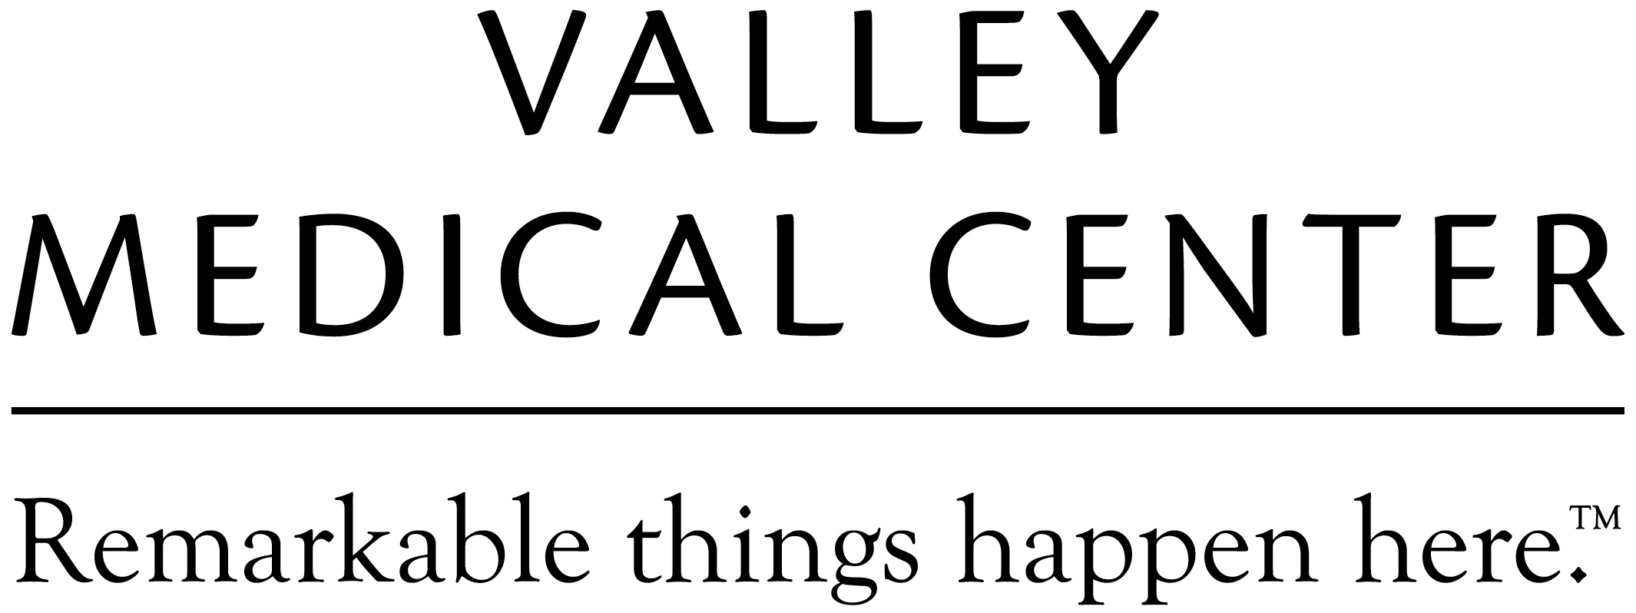
Valley Medical Center is currently recruiting for a
Human Resources Generalist!
Valley Medical Center is the largest nonprofit healthcare provider between Seattle and Tacoma, serving over 600,000 residents. Located in Renton, Washington, VMC offers medical, surgical and 24-hour emergency care as a Level III Trauma Center.
The Human Resources Generalist will administer programs, procedures and plans in order to institute and support human resources policies and procedures. They will provide consulting services to management and staff to promote equitable application of human resources employee relations polices throughout the organization. Areas of support can include employment, affirmative action, performance management, compensation, benefits, and training. This position will advise, counsel and assist in resolving job related concerns; perform internal complaint investigations; review and approve disciplinary actions to assure conformance to policy and consistency of practice.

Position Requirements:
Bachelor’s degree in Business Administration, HR or relevant field.
2-4 years of related experience
Demonstrated knowledge of human resources disciplines including: employee/labor relations, performance management, compensation, benefits and regulatory laws.
SPHR or PHR certification preferred
Healthcare industry experience preferred

Apply online at www.valleymed.org/careers
Human Resources Generalist

