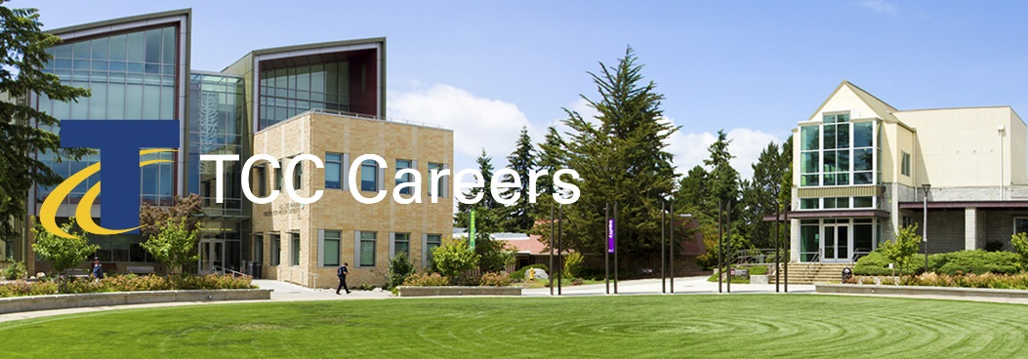 | We invite you to join us and be an active part of a multicultural environment dedicated to academic excellence.  Posting Date: January 2, 2020  Priority Date: February 2, 2020  Announcement: 20-01-AP #MON  Create Learning / Achieve Equity  Engage Community / Embrace Discovery

Business Systems Analyst

Priority Consideration Date: February 2, 2020

Position Summary
Responsible for providing a functional, technical and business analysis role for the implementation and on-going support of the ctcLink (PeopleSoft) administrative systems. Serve as the technical resource to all departments in the Finance and Human Resources divisions acting as a resource and liaison between Information Technology (IT) and the customer. Be proficient and manage all aspects of the ctcLink modules, specializing in Finance and Human Capital Management, and work as a liaison among department staff and project stakeholders to elicit, analyze, communicate, prioritize, clarify, validate and document requirements for changes to business processes and information systems in support of department and ctcLink objectives. Collaborate with IT and subject matter experts to develop query and reporting solutions within the ctcLink database. Provide a project and organizational change management role within and between departments and provide training/job aids and knowledge transfer to department staff where required. Administer ctcLink (PeopleSoft) access and permissions security. This position reports to the Director of Information Technology.

Essential Functions
- Support applications within all pillars of PeopleSoft, specializing in Accounting, Financial Services, Purchasing, Budget, Grants and Contracts, Payroll and Human Resources departments.
- Act as functional and technical lead and subject matter expert providing support for the ctcLink, specializing in Finance and Human Capital Management modules.
- Administer PeopleSoft access and permissions security.
- Coordinate with department managers and staff to identify needs, changes, testing and training of system implementation and upgrades.
- Perform data validation, integration and acceptance testing where needed.
- Create ad hoc queries and reports using PeopleSoft Query and other Business intelligence and data analysis tools.
- Work closely with local and SBCTC resources in support of ctcLink Finance and Human Capital modules.
- Provide Organizational Change Management (OCM) functions to promote continuous improvement, business process analysis, and adoption of available functionality within PeopleSoft.
- Provide ctcLink system and functional configurations within the Campus Solutions modules and work closely with the SBCTC personnel support desk analysts for support as required.
- Responsible for project coordination, planning and ensuring successful completion of project goals and milestones.
- Lead, review and test ctcLink updates including working with end users on new functionality and determine effect on current systems and business processes.
- Work closely with IT to develop and implement security/access strategies and solutions as well as database and data analysis solutions and tools.
- Perform other related duties as required and deemed appropriate in support of the Information Technology Department to accomplish assigned responsibilities and functions of the office.

Minimum Qualifications
- Associates degree in business, information technology or closely related field from an accredited college or university.
- Three years of experience in a technical and functional role providing business analysis and systems support for a college administrative information system and/or ERP.
- Three years of experience working with complex information systems and/or ERP.

Preferred Qualifications
- Bachelor’s degree or higher in business, information technology, or closely related field from an accredited college or university.
- Experience working in higher education.
- Five years of work experience with Finance and HR Information Systems.
- Functional leadership or Subject Matter Expert experience in PeopleSoft’s Finance and Human Capital Management module, including Hyperion and/or PeopleSoft Query.
- Experience in providing organizational change management and business processes improvement solutions and tools.
- Certification(s) in Project Management, Change Management, ITIL, Lean and/or Business Process Reengineering, or other directly applicable areas.

Conditions of Employment
- Successfully complete a criminal history background check.

The Successful Candidate Must Demonstrate
- Strong analytical and problem solving skills.
- Strong, effective organizational and interpersonal skills, and customer-service and teamwork oriented.
- Excellent communication skills including verbal, written and active listening.
- Advanced experience with word processing, spreadsheet, database, report writing software.
- Ability to work effectively and collaboratively with clients, staff and management with minimum direction.
- Ability to manage multiple competing priorities and work under pressure in high stress situations.
- Dependability, accountability and the ability to maintain progress on tasks without supervision.
- Critical thinking skills and strong skills in consensus building and problem solving.
- Understanding of college and community organizations.
- Ability to relate well to diverse populations, students, faculty, staff and the general public in a friendly, courteous, respectful and professional manner.
- An appreciation of diversity and the benefits of a commitment to cultural awareness and sensitivity in the workplace.
- Ethics and integrity, and sound professional judgment.

Application Materials & Procedures
Complete application packages must include the following. Selected candidates will be invited for interview.
- Resume
- Cover letter, describing how your educational background and experience align with the responsibilities and qualifications.
- Copies of transcripts for all colleges and universities attended.
- Tacoma Community College is committed to creating and supporting a multi-cultural climate that welcomes, fosters, respects, and celebrates diversity. Please attach a statement (maximum two pages) describing your experiences with other cultures and communities, your level of cultural self-awareness and how you have integrated both experience and self-awareness into your living/working environment.
Terms of Employment
This is a full-time exempt administrative position contracted on an annual basis. The salary for this position is $84,711.00. The salary will be prorated to reflect the actual number of contract days worked in the remainder of the fiscal year. Flexibility in scheduling is required to meet the needs of the department. Degrees must be from accredited colleges or universities recognized by the U.S. Department of Education and verified by National Student Clearinghouse.

Tacoma Community College values diversity and is an Equal Opportunity Employer and Educator
Tacoma Community College provides equal opportunity in education and employment and does not discriminate on the basis of race, color, national origin, age, disability, genetic information, sex, sexual orientation, marital status, creed, religion, or status as a veteran of war. Prohibited sex discrimination includes sexual harassment (unwelcome sexual conduct of various types). Provides reasonable accommodations for qualified students, employees, and applicants with disabilities in accordance with the Americans with Disabilities Act and Federal Rehabilitation Act. The following persons have been designated to handle inquiries regarding non-discrimination policies: Stephen Smith, Title II and Title IX, 253-566-5055; Dolores Haugen, Section 504 Officer, 253-566-6090. Tacoma Community College is a smoke-free/drug free environment. This recruitment announcement does not reflect the entire job description and can be changed and or modified without notice.

Tacoma Community College
Human Resources
6501 S 19th St Bldg. 14, Tacoma WA 98466
www.tacomacc.edu/about/employment

